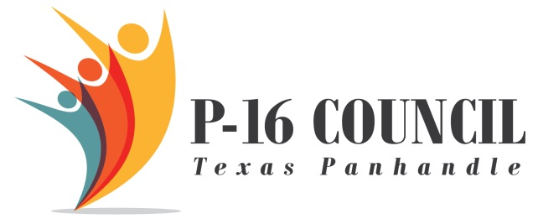

Patient Care Technician
Certification Course
Texas Essential Knowledge & Skills
and
Scope and Sequence

